# CS 255 Business Requirements Document Template

## System Components and Design

### Purpose

* DriverPass is the client for this project
* The purpose of the system is to:
* Train customers to pass the drivers license test
* Improve pass rates for driving tests
* Store customer information
* Allow the creation of appointments by both the customer and receptionist
* Allow the creation of customer accounts
* The customer can manage their account and take their classes all online

### System Background

* DriverPass sees the failure rate of driving tests at the DMV to be a big problem in society
* DriverPass plans on contributing to solving this problem by making driver education and training more accessible for people preparing to get licensed
* More specifically they wants to offer online classes and practice tests as well as in person driver training
* We will need to create several different kinds of accounts with varying levels of access. The administrator account should have full access to the system with the ability to edit view any of its aspects as well as run commands.
* The secretary account type should have the ability to create new user accounts, sign them up for classes, make driving appointments for them and cancel or change their education plan.
* The user account type should only be able to edit and view its own account. They should be able to buy or cancel educational plans and make or change driving appointments for their own account.

### Objectives and Goals

* Allow the customer to be able to create their own account online
* This should allow the customer to be able to create and change appointments entirely online
* The customer should also be able to see their progress on their profile page as well as driver notes
* Customer needs to be able to automatically reset their password using the system
* The system should notify DriverPass whenever the DMV makes an update to their rules and regulations
* System should be cloud based so that security and backups are automatically taken care of
* The customer or secretary must be able to access a page where they can update student information
* There should be two contact pages one the student can access with DriverPass’s contact info and another page that only DriverPass can access with student contact information.
* System needs the ability to download data as excel sheets for offline use
* Needs to be support for online classes and tests
* DriverPass needs to be able to view the drivers notes in a tabled format including the times of the lessons
* DriverPass needs to able to disable learning modules if they no longer want them available
* We need to create different levels of access for different users, for example the manager needs to be able to block account access if employees are let go
* The customer can register for classes by either calling and going through an secretary of the company or signing up by themselves online
* The customer should be able to select from several different educational packages that are explained either by the secretary working with the customer or the description on the website.
* The administrators would like the ability to track all changes made to the system as well as driver, car and customer statuses and relationships.
* The administrator of the system should be notified whenever a change is made to the system and be able to view and manage customer sign ups and cancellations, driver assignments to clients and vehicles, when a driver checks in and out a vehicle and the status of a customer's progress in the course.

## Requirements

### Nonfunctional Requirements

#### Performance Requirements

* The system should be able to be accessed by all the major web browsers(Chrome,Firefox,etc)
* The system should have an average response time of 5 seconds or less for each user request
* The client should be synced with the server every 10 minutes to update information
* The whole system should be backed up every 6 hours to minimize damage in case of a malfunction
* The development team should add security updates as potential breaches are discovered.
* (Dennis et al., 2012)

#### Platform Constraints

* The system should have primary support for Windows and macOS as that is what almost all potential customers would have access to.
* Support for linux distributions should not be a priority but can be done if time and budget allows
* The system would need to have a database that stores all the information about classes, customers, drivers etc.
* (Dennis et al., 2012)

#### Accuracy and Precision

* There will be three different types of accounts admins, secretary and customer
* All three accounts will have the same sign in page but different credentials
* Users will have varying levels of access to the system depending on what type of account was verified by the system's authenticator. Input should be case sensitive to allow for more security by creating a larger pool of possible usernames and passwords and also to minimize ambiguity in language.
* They system should notify the admin every time an error is produced in the system or a user is locked out for too many incorrect login attempts.
* (Dennis et al., 2012)

#### Adaptability

* The customer should be able to create a new account, modify their existing account or delete their account using existing infrastructure. The access to modify is limited to the account that is signed in.
* IT admins should have the ability to add, modify or remove any account in the system using existing infrastructure.
* The secretary account should have the ability to add, modify or remove any account using existing infrastructure.
* The IT admin should be have the ability to edit class offerings and driver assignments
* The system should be able to handle updates from both the operating systems and web browsers that it runs on
* (Dennis et al., 2012)

#### Security

* The user will need a username and password to login to their account
* All information exchanged between the client and server should be encrypted
* The system will have a forgot password button that can help the user create a new password by verifying their identity through other means.
* The system will lock out any account after 5 failed login attempts to prevent brute force hacking. The account will have to be unlocked by the administrator account.
* (Dennis et al., 2012)

### Functional Requirements

* The system will validate user credentials when a login is attempted
* The system will allow the customer to create an account and select a package to purchase
* The system will allow the secretary account to create an account and select a package on behalf of the customer
* The system will allow the customer to access their classes and interact with them as necessary
* The system will keep a record of all information pertaining to driver,customers and classes and have it readily available to the admin
* The system will allow the customer or secretary to schedule driving appointments
* The system will have a contact page accessible to the student where they can find out how to contact DriverPass
* There will be a contact page only accessible to the admin and secretary accounts that has all student contact information
* The system will have a page where information is laid out for the admin account including driver notes, customer information and customer progress in their course
* The system will check with the DMV site for updates to rules and regulations and notify the admin of any changes
* The system will report all changes made to the admin with information related to the change including who made the reservation and who last modified or cancelled it.
* The system should have a chart accessible to the admin detailing driver assignments to customers.
* The system will allow the admin to download reports of customer, driver and system information for offline use.
* The system will be available and fully functional to all users 24/7 aside from scheduled maintenance
* (Dennis et al., 2012)

### User Interface

*What are the needs of the interface? Who are the different users for this interface? What will each user need to be able to do through the interface? How will the user interact with the interface (mobile, browser, etc.)?*

* The interface must have a login page where the user can enter their credentials and sign in
* The customer will be able to enter their information upon making an account and select an educational package
* The customer will be able to click and access their account to modify it at any time
* The customer will be able to click and access their online classes
* The customer will be able to reserve a driving time with a driver through a webpage in the system
* The admin will be able to view and interact with any account in the system
* The admin will be able to access a page where system data can be downloaded
* The secretary upon logging in will have access to the account management page where they can add,modify or remove accounts
* The mobile interface should be optimized for touchscreens with larger buttons and resized pages
* (Dennis et al., 2012)

### Assumptions

* The user of the system should have a modern computer with average power capabilities
* The user will have an updated OS and web browser
* We gathered enough information at the interview to make proper judgements
* There will be no delays in development and we will have a competent and fully staffed development team
* The database will be available constantly to the client as needed
* DriverPass will acquire adequate cloud computing capabilities for this system
* (Usmani, 2021)

### 

### 

### Limitations

* We want to get the project done by May 10th
* We have to stay within the budget limitations of DriverPass
* We have to make sure that they system is able to be run by the average consumers computer
* The website should not require a lot of data to function and be able to be run on an average internet connection
* (Usmani, 2021)

### Gantt Chart

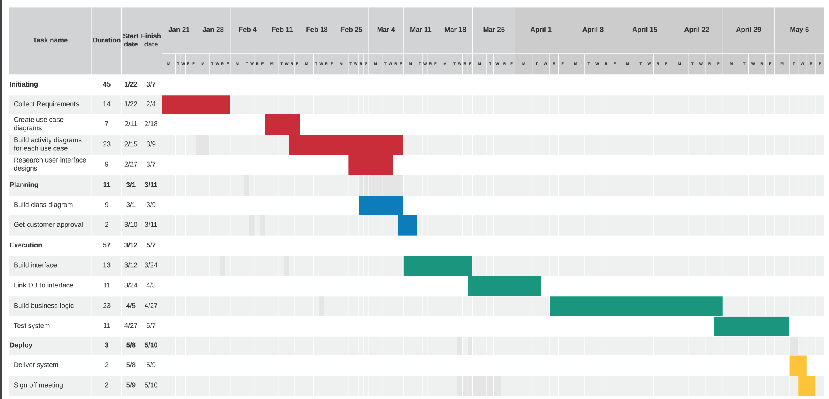

References

Dennis, A., Wixom, B. H., &amp; Tegarden, D. (2012, February). Systems analysis and design with Uml, 4th edition. O'Reilly Online Learning. Retrieved September 30, 2021, from https://learning.oreilly.com/library/view/systems-analysis-and/9781118037423/08_chapter003.html#ch003-sec005.

Usmani, F. (2021, September 2). Assumptions and constraints in project management. PM Study Circle. Retrieved September 30, 2021, from https://pmstudycircle.com/assumptions-and-constraints-in-project-management/.